Introduction:

My goal is to develop an innovative language-learning application powered by Llama2. The USP of my app is to provide an interactive learning experience that is personalized to meet individual needs.

Objective:

My application aims to increase the interest and efficiency of the learning process by leveraging the capabilities of Llama2. It addresses the challenge of lack of personalization and interactivity in traditional language learning methods.

Proposed Solution:

My app will provide a comprehensive set of language learning tools, including a vocabulary generator, reading comprehension exercises, writing exercises, translation help, and quizzes. Llama2 will be integrated into each component to provide a personalized learning experience and intelligent feedback. Users will interact with the application by engaging in activities and receiving real-time feedback, enabling them to learn the language more effectively.

For the vocabulary generator, users need to provide the fields they want to enhance or learn, we will give them some words to remember.

For reading comprehension exercises, users need to provide their levels of specific language.

For writing exercises, users need to provide the article type they want to practice, such as an argumentative essay or narrative essay, they can also provide the aspects they are interested in, and we will give them some subjects and examples.

For translation help, users just need to provide origin sentences and their destination language.

For quizzes, users need to provide a theme, and we will help them to generate some practices.

All of these components will interact with Llama2, I think that will be interesting while in using.

Technology Stack:

I will use Android Studio for development and Java as the programming language. The following diagram shows the interaction between application components and Llama2:

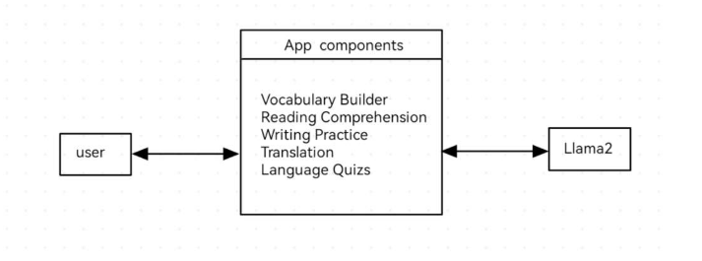

Development Methodology:

I plan to adopt agile development method because of its flexibility and iteration. Agile methods allow for continuous improvement based on user feedback, which is essential for projects focused on delivering personalized learning experiences.

Conclusion:

I present a language learning application, powered by Llama2, that aims to change the way languages are learned by providing a personalized, interactive, and effective learning experience.